Game Design Document Group 5

Hunter Horror

Copyright @ 2022 by CSC 427 Group 5

Written by Peter Cruciata

Version # 0.1

Table of Contents

Design History 3-4

Game Overview 5-7

Gameplay and Mechanics 8-11

Story, Setting and Characters 12-15

Levels 16-17

Interface 18

Artificial Intelligence 19

Technical 20

Game Art 21-24

Management 25

Appendices 26-29

Design History

Version 0.1.1

Early conceptual designs. Mapping remains small open area. Main player character and enemy character are represented by two place holder game objects. Early builds allowed the exploration of player movement.

Version 0.1.2

Building upon our early design, in this version we began updating the player and enemy to interact with each other.

Version 0.1.3

Moved to first person perspective. Other game scenes have been added in. Addition of title screen, victory screen, lose screen, options menu, how to play menu, buttons. Game play updated drastically at this point. Map was added to main scene, the player will now walk around a maze to look for interactables.

Version 0.1.4

Interactables added, scene transitions, sounds and other polish added.

Version 0.1.5

Sounds added, player torch added, magic stones added

Version 0.1.6

Bug Fixes

Game Overview

Game Concept:

The concept of the game is to be an immersive first-person horror game in which you are trapped in a maze with a monster who is tracking you as you walk around. Your goal will be to collect all the keys and escape the maze while being hunted. The game will use atmosphere and dark and dim lighting in order to set the mood for the horror aspect.

Feature Set:

Player Character will be able to walk in all cardinal directions, but will have to obey laws of physics. (Will not be able to walk through objects or fly). They player will be allowed to collect items whether collectable of power ups. The player will need to avoid the enemy hunter as the will have no ability to fight them, the players only objective should be escape. The player wins when the escape the dungeon. The player will lose if all their lives are depleted from being killed by the hunter

Genre:

This game is an atmospheric horror game, with survival elements.

Target Audience:

The game is targeted to reach a wide range of people. We intend for the game to be played and enjoyed by everyone, but we expect it will attract a demographic of horror fans in their teens.

Game Flow:

The game is intended to be a winding maze so they will have many places to walk but it will all be contained within the one maze. The player will navigate their way through the maze looking for the items necessary to escape. The player can move anywhere within the maze in order to look for the items to escape as they will all be present upon spawn, but they will need to avoid the enemy. The game will be in 3-D with movement along the x,y, and z axis. The maze has verticality to it so the player can move up and down, but they cannot jump on their own.

Look and Feel:

The game is set to be in a maze with many winding paths. The horror elements are added through the ambiance and the mood that is set with lighting and sounds. The setting is dim with limited forward vision and a dark mysterious feel that is meant to make you concerned with what could be around the corner.

Project Scope

Number of Locations:

The game is located in one place, the maze. The maze is large and contains many winding paths and will offer the player much mystery to explore

Number of Levels:

There is one level. It is the designed maze. It is multi floored maze and has many branching paths. There is a room that the player can deposit all of the collected keys for a victory.

Number of NPCs:

There is one enemy and it is the AI controlled hunter.

Number of Weapons:

The Player is defenseless armed only with his wits.

Gameplay and Mechanics

Gameplay

Game Progression:

The game progresses as you collect the items within the maze. Your job as the player is to collect 5 keys and make your way to the exit to win the game.

Mission / Challenge Structure:

The games one mission is to escape the maze by finding the collectibles to exit. The challenge structure comes from navigating the maze and avoiding the hunter who is trying to kill you as you look for the items.

Puzzle Structure:

Objectives:

The objective of the game is to spawn into the maze and escape. You will do this by navigating your way through the maze and looking for keys that allow you to open the exit door to leave. Alternatively, you have to stay alive and not be caught buy the killer and lose all your lives while you do this.

Play Flow:

The gameplay is meant to be free formed, while you have a primary objective of needing to collect the items the game is not going to push you in any direction. You can freely explore your surroundings in order to complete the objective.

Mechanics

Physics:

The games universe rules are based on real life. The player character has no special abilities or any special powers. The player can walk in all cardinal directions and pick up collectibles.

Movement:

The player character moves at a neutral walk speed, the player can move in all the cardinal directions and walk up and down stairs. The player also has the ability to sprint however the sprint is on a cooldown and will need time to recharge after being depleted. The player can also jump.

Objects:

The game has key objects which serve as collectibles needed to escape the maze. There are also magic stones.

Actions:

The player can interact with the collectibles. They can also sprint with a button press.

Combat:

The player cannot preform any active combat as there is no way for the player character to fight, however the player has lives and will lose them upon being caught so they have to maintain their health while playing in order to win.

Economy:

Screen Flow:

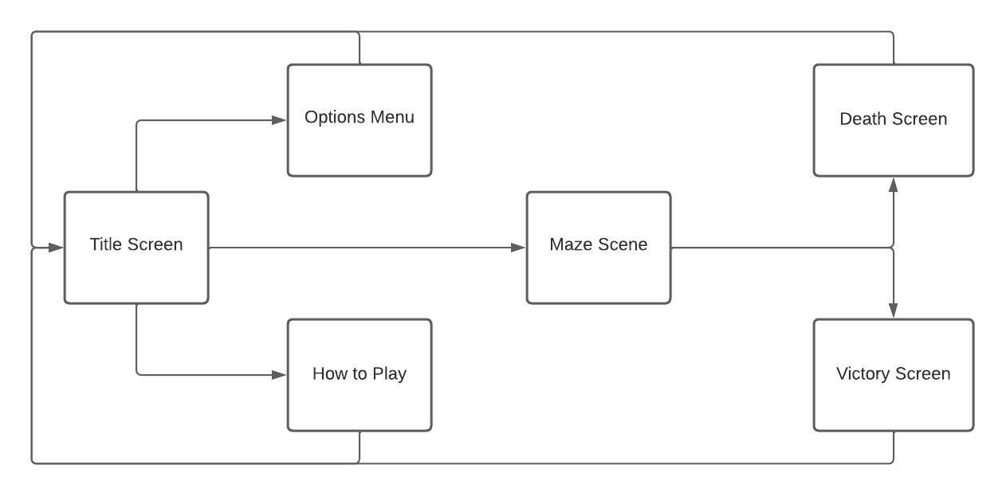

Screen Description:

Upon opening the game, you are introduced to a title screen with 3 buttons. Play, options, and How to Play if you choose to check out the options menu or the how to play screen you will be brought to those screens form a button press on the title screen. The options and how to play menus have a back button that will return you to the main title screen. If you press the play button you will be brought to the game. If you win the game, you will be brought to the victory screen, from the victory screen you can be brought back to the title screen. If you lose you will be brought to the lose screen. From the lose screen you can press the home button to return to the title screen.

Replaying and Saving:

The game has no save function as it is short and meant to be beaten in one run. Replaying comes in the form of beating the game and returning to the title screen and being able to play it again.

Cheats and Easter Eggs:

There are no cheats in the game it is made to be played honestly. There are also no easter eggs.

Story, Setting and Character

Story and Narrative

Back story:

You are a weary traveler lost in a maze inhabited by a monster looking to kill you. Your only means of escape is collecting the items and leaving the maze. The game is shown to have a horror vibe.

Plot Elements:

The game is not driven by its story. It is a game that has a backstory shown through its title and ambience set through gameplay.

Game Progression:

The game progresses in a free-form way. You can move throughout the maze in a way that you see fit. You will need to get all the collectibles in order to escape the maze and win the game.

License Considerations:

For the story and characters no licensing would be needed. These characters have all been designed for the purpose of this game

Cutscenes:

The game has no cutscenes.

Game World:

General look and feel of the world:

The world is based on generic horror tropes. Lost in an area that a monster knows better than you. The area is dark and dingy, light only comes from the glow of the torches on the walls. The maze is cold and made of yellow blocks that resemble sandstone. The sounds are unsettling. Water droplets, moans, and the pitter patter of yours and the monsters’ feet.

Maze:

The maze is our only level but it is large and winding. It contains many paths and corridors that are hiding secrets that you need to find in order to escape.

Characters:

Character #1:

Player character is not seen by the player. The game takes place in first person so you never see what you look like.

Personality:

The player character. has no personal characteristics they have no emotions or motivations they are an empty slate that the player can project themselves onto.

Look:

Physical Characteristics:

Animations:

Special Abilities:

Relevance to game story:

The player character is the main character of the story they drive the game forward through the gameplay we players project onto them.

Relationships to the other characters:

The player character is being hunted by the enemy character. They have no relationship outside what is being displayed in the gameplay. The player character was just unfortunate enough to be found by the killer.

Statistics:

Character #2:

The enemy is the only other character in the game. The AI is meant to track and hunt the player character as they move around the map

Personality:

Look:

Physical Characteristics:

Will fill in   
Animations:

Will fill in

Special Abilities:

Relevance to Game Story

The hunter’s objective is to stop the player from escaping the maze.

Relationships to other characters:

The hunter is exactly that. It has the player character trapped in its maze and is doing nothing more or less than to make sure it secures the kill

Statistics:

Levels

Level 1:

Synopsis:

The gameplay opens up as you spawn into the maze. You can begin to walk around the winding corridors of the area surrounding you. The maze contains many paths and many dead ends.

Introductory Material:

The game is explained on a how to screen that can be accessed from the main menu. It explains the rules and the motivation of the player character.

Objectives:

The objective is to collect the keys and make it to the area in which you can use those keys to escape. The escape can only occur from a specific spot in the maze that you will be expected to find just like the collectibles. Once all keys are obtained you will be allowed to exit.

Physical Description:

The maze is dark and winding with many directions to go. The walls are high up so the player cannot look over them. The walls are lined with torches as your only source of light. The walls are gray stone.

Map:

Critical Path:

The game does not force you to go in any specific direction, you are only limited by the shape of the maze and the pathing of the enemy. Your goal is to work to find all the keys and then find the exit.

Encounters:

The player can encounter the hunter. The hunter will track the player as they go through the maze. The player cannot do anything in the encounter and will need to runway or lose a life.

Level Walkthrough:

Walk through the maze in order to find all 5 keys. Upon finding the keys make your way to the end zone where you can deposit the keys to win the game

Closing Material:

After you escape the maze, you will be brought to a victory screen that will allow you to either quit the application or return to the main menu. If at any point you lose all your lives you will be brought to the lose screen in which you can be brought to the main menu to try again.

Training Level:

There are no training levels. A light tutorial is given via text in a how to play section of the menus.

Interface

Visual System:

Control System:

The player controls the game by using the WASD buttons or the arrow keys to move. You can jump with the space bar and you can sprint with LShift

Audio:

244310__johnsonbrandediting__walking-on-pavement – FreeSounds.org – Player Walking

319103__abunijmeh__heavy-breathing – FreeSounds.org- Player Running

413175__micahlg__male-hurt10 – FreeSounds.org – Player Hurt

Music:

Free Horror Ambience 2 N91Music - HA – Distillery – Intro Music

Sound Effects:

Help Systems:

Artificial Intelligence

Opponent AI:

Enemy AI:

Non-combat Characters:

Friendly Characters:

Support AI:

Player and Collision Detection:

The player collision stops the player from walking through walls and structures. The player hitbox can collide with the enemy hit box. If the enemy hit box collides with the player hurt box the player will take damage.

Pathfinding:

The enemies will path towards the player but no specific pathing instructions are given.

Technical

Target Hardware:

The game is targeted towards all types of systems. It isn’t too demanding technically and should be able to run on most systems.

Development Hardware and Software:

The software used to develop this game was C# and unity. Unity was used for map layouts and hitboxes and prefabs along with scene construction. C# was used to create the scripts for the enemy and player characters.

Development procedures and Standards:

Game Engine:

Unity

Network:

Scripting Language:

C#

Game Art

Concept Art:

Style Guides:

Characters:

Enemy:

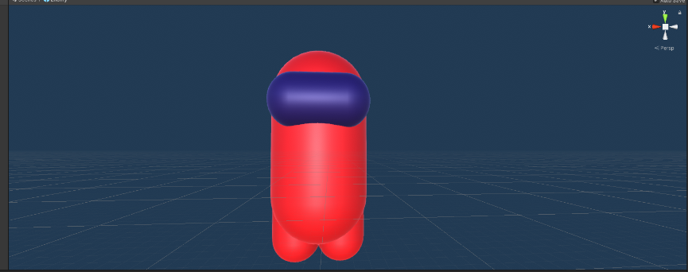

Player

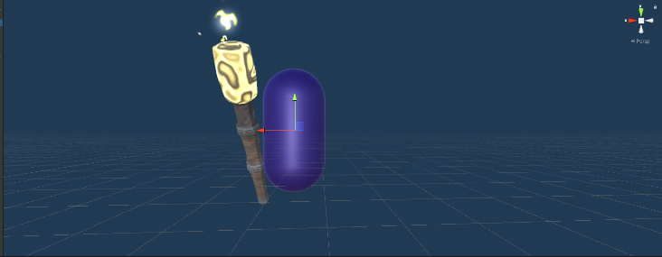

Environments:

Equipment:

Cut Scenes:

Title Screen:

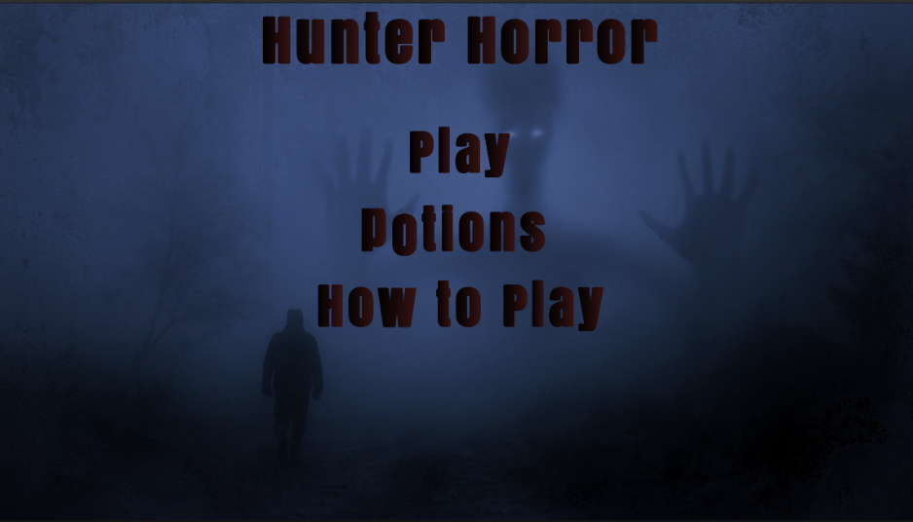

Options Menu:

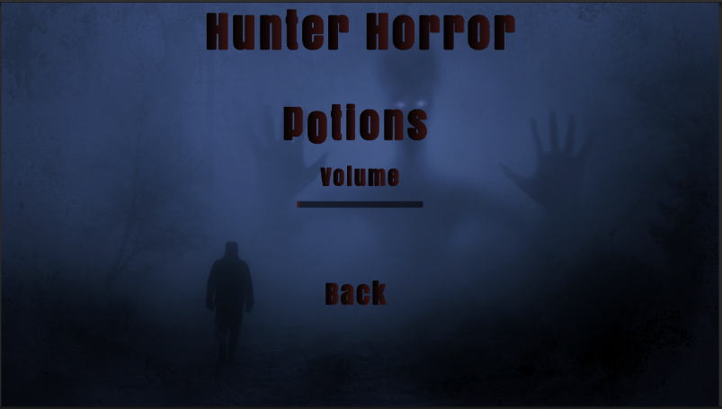

How To Play Menu:

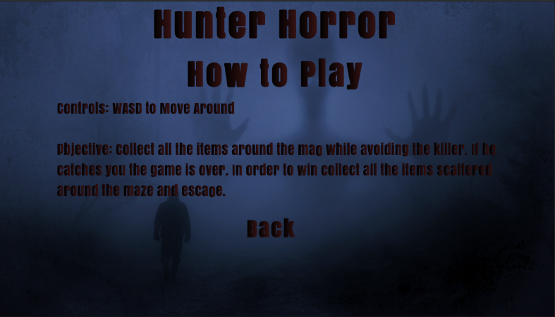

Death Screen:

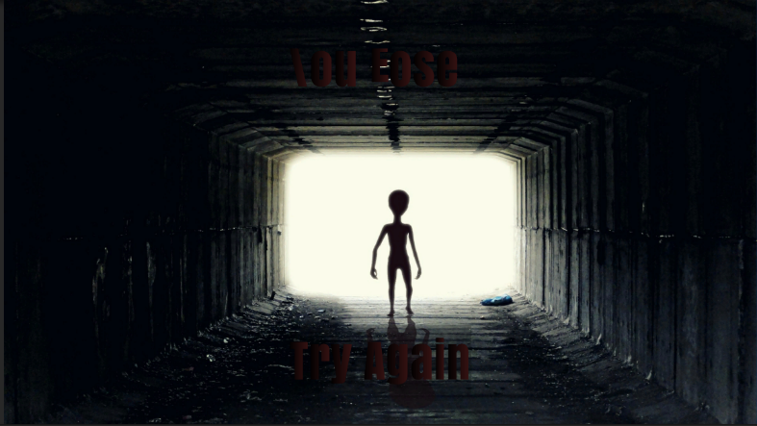

Victory Screen:

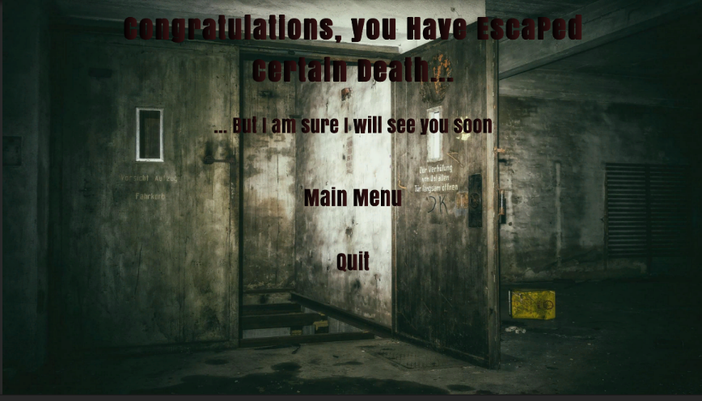

Misc:

Images Used for Scenes:

Fantasy Spirit Nightmare Dream – KellePics - https://pixabay.com/photos/fantasy-spirit-nightmare-dream-2847724/

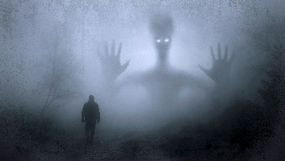

Ufo alien guy pozaziemianin – Pawel86- <https://pixabay.com/photos/ufo-alien-guy-pozaziemianin-2413965/>

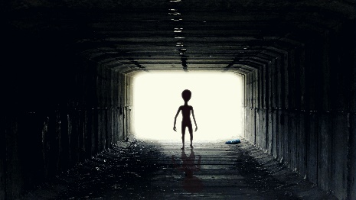

Lost Places elevator underground – Tama66 - https://pixabay.com/photos/lost-places-elevator-underground-1928727/

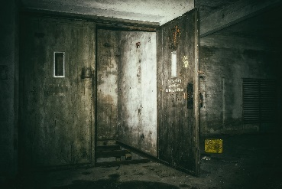

Management

Detailed Schedule:

Work Log Document

Budget:

Risk Analysis:

Localization Plan:

Test Plan:

Appendices

Model and Texture List:

StoneWalls Normal Maps- BigMiniGeek

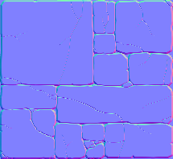 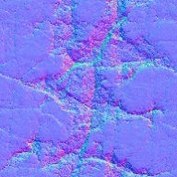 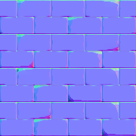 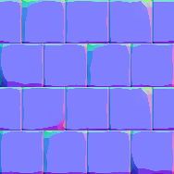

Normal Maps Textures Rock CliffVolcanic- Roughness

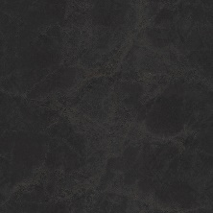 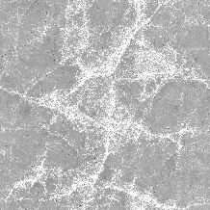 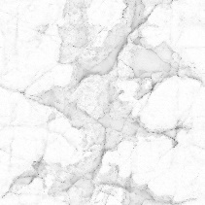

Handpainted Keys- RoboCG

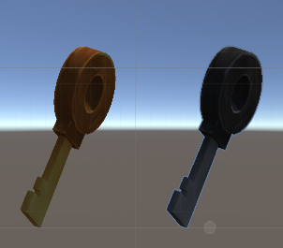

Gold and Silver Key

Handpainted Keys- RoboCG – Textures

Health Bar- Bar

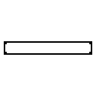

Torch and Key UI elements.



Table for Keys

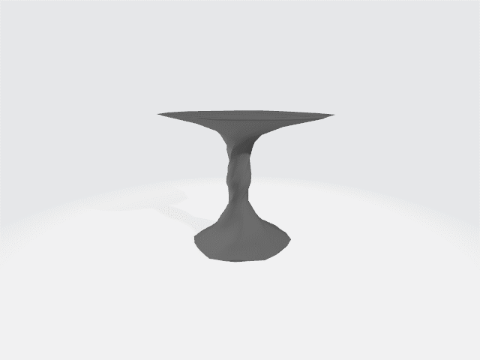

https://sketchfab.com/3d-models/stylised-lock-texture-practice-59ea19c9ab4e4f92b9a7d8500cad62b0

Chains for key Locks on end zone

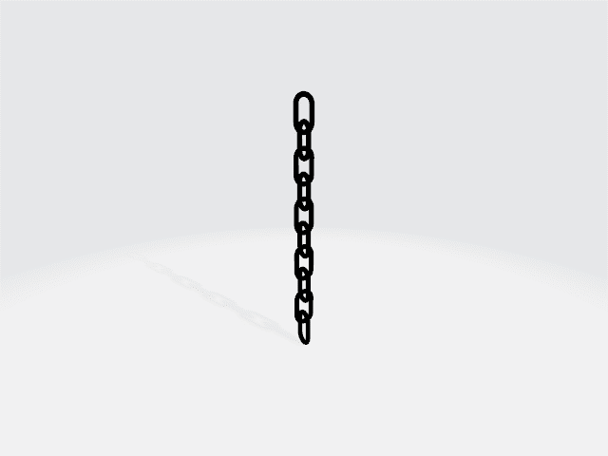

https://sketchfab.com/3d-models/iron-chain-6d079f01c7c142e0be54d7f2d33b33e6

Key Lock



https://sketchfab.com/3d-models/magic-diamond-6d3498168d5249d4a837f5a12bad69f3

Magic Stone  
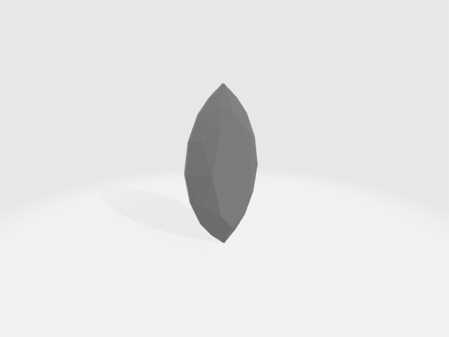

Fire Torch Mech

Braziers and Pillars

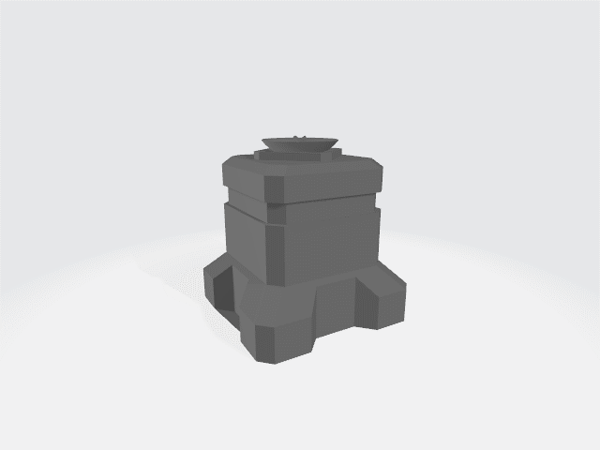

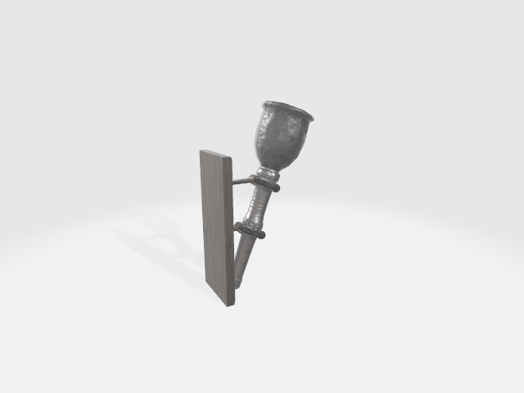

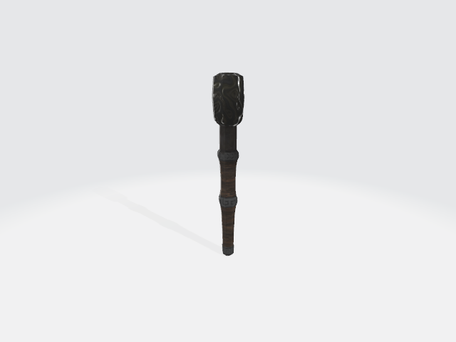

<https://sketchfab.com/3d-models/wind-chimes-bell-52d024107eb04624b5cbc6d909831880>

Wind Chimes

